a [0] = new double [10]

*Internetworking*

OSI Model:

7.Application Layer

6. Presentation Layer

5. Session Layer -

4. Transport Layer – Transmission Control Protocol /User Diagram Protocol (UDP)

3. Network Layer

2. Data Link

1. Physical Link

TCP/IP Model:

5. Application level (which covers 7,6,5 in the OSI model)

4. Transport

3. Network – IP address

2. Data layer

1. Physical level

Network mapping:

Square with an “x” in the center is a switch

Circle with an “x” in the middle is a router

Straight line - Through line

Dotted line -- Cross over cable

Squiggly line – WAN cable

Shielded Twisted Pair (STP)

Unshielded Twisted Pair (UTP)

Through cable – one device to another kind

Crossover cable – to like devices.

Optics:

Multi mode

Single mode

Computer hubs – antiquated machine that can generate loops. The hub receives a packet and send the packet out of every port in the machine.

WAN – wide area network

PAN – personal area networks

MAN – metropolitan area network. (city wide - one provider)

LAN – local area network

Port on desk

1 connects to router

2 connects to switch

3 LAN connection

4 empty

5 empty

6 internet connections

TCP/IP Networking Model

Adjacent Layer interactions – refers to the concepts of how adjacent layers in Networking model on the same computer, work together. Ie the higher-level Http wants error recover so it uses the lower level protocol (transport TCP layer).

Same-layer interaction – when a particular layer on the computer want to communicate with the same layer on another computer, the two computers use headers to hold the information they want to communicate.

TCP/IP Model:

5. Application level

HTTP header on packet frame that fetches request from server

4. Transport

TCCP Error recovery Basics

- TCP message is called a segment has a sequence number, when one of those segments fails to deliver then the client computer will request that segment again.

3. Network – IP protocol

2. Data layer -header and tail!

1. Physical level

Internetworking Class 2

IP

Public vs private IP

Subnet masks

Class A: 0-128^-1 255.0.0.0

Class B: 128-192^-1 255.255.0.0

Class C: 192 – 224^-1 255.255.255.0

(there are class D and E use for research)

Private class IP address

10.0.0.0 – 10.255.255.255

172.16.0.0 – 172.31.255.255

192.168.0.0 – 168.255.255

Network address will always have an even address(except in /32 subnet masks)

Broad cast address is always odd!

Class 3: VLAN

VLAN provide security and separation of data.

Trunk line – will allow any packets to pass through regardless of packet specification.

VTP – variable trunking protocol: allows us to set up a master for the other devices.

Spanning tree - that prevents loops (complicated formula to determine the best device to route traffic) every 30 to 45 seconds the STP will automatically send an STP frame to verify the best route and determine loops – and send information accordingly.

Class 4: (Routing) 2/13/2020

Cisco Switch ports are normal open to communicate with any device on the device. Routers are the exact opposite. Every interface needs it’s own ip address.

Setting static IP address in CLI on cisco routers: you must be in global config type in:

IP Route *some ip address*

*Class 4 - 2/20/20.*

*Open Shortest Path First*

*Inverse binary relationship*

*Routers only care about what is connect to it.*

*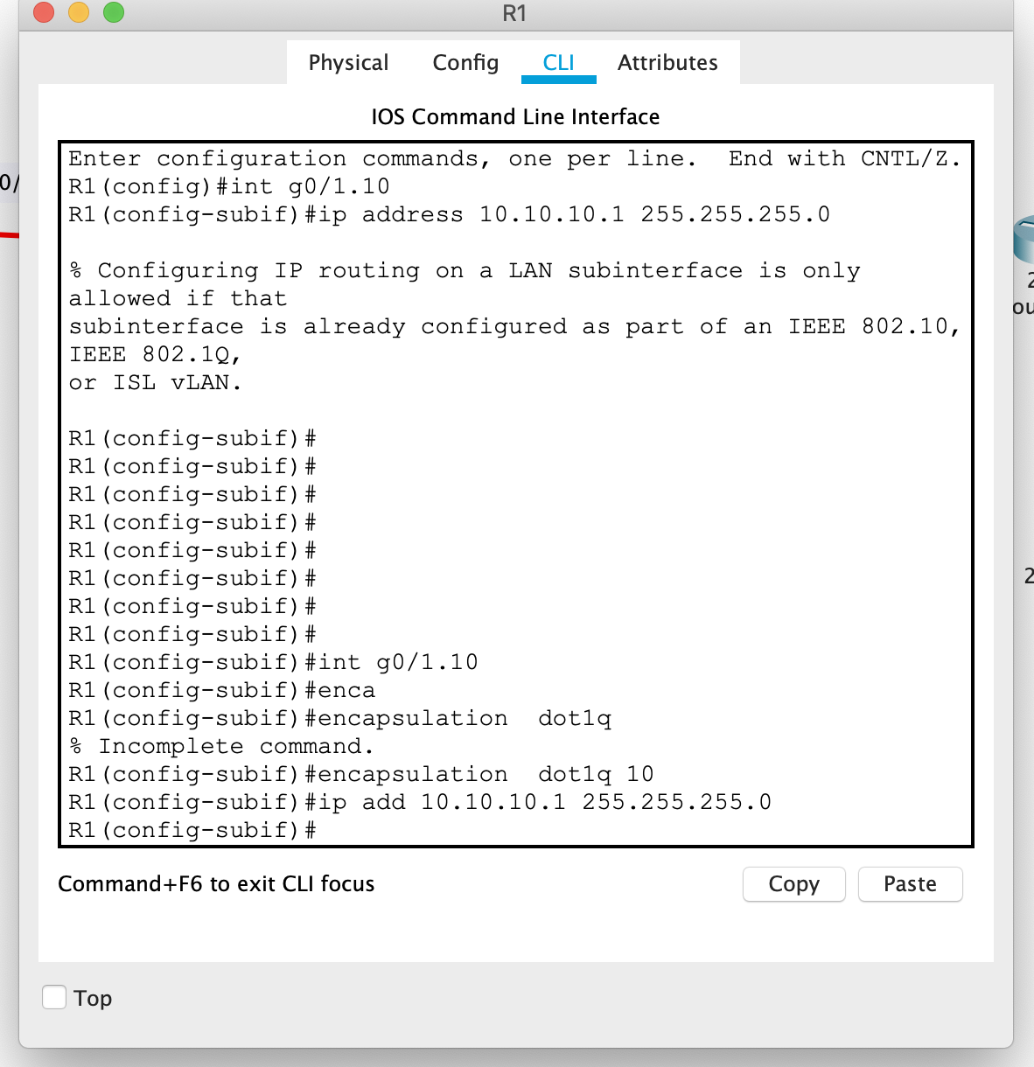*

*Sub interface commands*

*2/27/2020*

*ACL – Access control lists*

*Out vs IN*

*Standard = 1-99. Checks for IP Address.*

*Extended = 100 -199 check for ports (FTP, Web, etc..)*

*Permit vs deny*

*Rule 1, rule 2, rule 3…. Rule X*

*Where x is the last rule on the list is reserved for deny all option. Deny all is set by default. & rule X-1 is an option for permit any, which is explicitly stated. Each rule is basically an “if-statement.”*

standard is closest to the destination

extended is closest to the source

NAT AND PAT  
Network address translation – uses ip address

Port address translation – uses port number between 1 -~65000 the port refers to the port with in the packet